**Practical No. 2**

**Implementation of Remote Procedure Call**

**Q.1 . Write a java program to implement a Server calculator using RPC concept. (Make use of datagram).**

**Structure :**

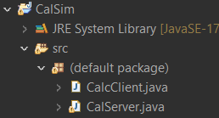

**Program :**

**CalcClient.java**

import java.io.BufferedReader;

import java.io.DataInputStream;

import java.io.DataOutputStream;

import java.io.InputStreamReader;

import java.net.Socket;

public class CalcClient {

Socket socket;

int port;

public CalcClient(int port) {

this.port=port;

}

public void sndReq() throws Exception{

socket=new Socket("localhost",port);

DataInputStream din=new DataInputStream(socket.getInputStream());

DataOutputStream dout=new DataOutputStream(socket.getOutputStream());

BufferedReader in=new BufferedReader(new InputStreamReader(System.in));

String str="";

int num1,num2;

System.out.println("1:Addition \n2:Sub \n3:Multi \n4:Div \n5:Exit");

System.out.println("Enter your choice ");

int choice=Integer.parseInt(in.readLine());

System.out.println("Val=" +choice);

switch(choice) {

case 1:

str += choice+"-";

System.out.println("Enter 1st Number\n");

num1 =Integer.parseInt(in.readLine());

str +=num1+"-";

System.out.println("Enter 2nd Number\n");

num2 =Integer.parseInt(in.readLine());

str +=num2+"-";

break;

case 2:

str += choice+"-";

System.out.println("Enter 1st Number");

num1 =Integer.parseInt(in.readLine());

str +=num1+"-";

System.out.println("Enter 2nd Number");

num2 =Integer.parseInt(in.readLine());

str +=num2+"-";

break;

case 3:

str += choice+"-";

System.out.println("Enter 1st Number");

num1 =Integer.parseInt(in.readLine());

str +=num1+"-";

System.out.println("Enter 2nd Number");

num2 =Integer.parseInt(in.readLine());

str +=num2+"-";

break;

case 4:

str += choice+"-";

System.out.println("Enter 1st Number");

num1 =Integer.parseInt(in.readLine());

str +=num1+"-";

System.out.println("Enter 2nd Number");

num2 =Integer.parseInt(in.readLine());

str +=num2+"-";

break;

case 5:

System.out.println("Program Exited!");

break;

default:

System.out.println("Invalid option!");

break;

}

System.out.println(str);

dout.writeUTF(str);

dout.flush();

String result=din.readUTF();

System.out.println("Result is"+result);

din.close();

dout.close();

socket.close();

}

public static void main(String[] args) {

// TODO Auto-generated method stub

try {

CalcClient cc=new CalcClient(5000);

cc.sndReq();

}

catch (Exception e) {

// TODO: handle exception

System.out.println(e.getMessage());

}

}

}

**CalcServer.java**

import java.io.DataInputStream;

import java.io.DataOutputStream;

import java.net.ServerSocket;

import java.net.Socket;

import java.security.PublicKey;

import java.util.StringTokenizer;

public class CalServer {

int port;

ServerSocket ss;

Socket socket;

public CalServer() {

this.port=0;

}

public CalServer(int port) {

this.port=port;

}

public double addition(int n1,int n2) {

return n1+n2;

}

public double sub(int n1,int n2) {

return n1-n2;

}

public double mul(int n1,int n2) {

return n1*n2;

}

public double div(int n1,int n2) {

return n1/n2;

}

public void listen() {

try {

System.out.println("Server started\n");

ss=new ServerSocket(port);

socket=ss.accept();

DataInputStream dis=new DataInputStream(socket.getInputStream());

DataOutputStream dout=new DataOutputStream(socket.getOutputStream());

double result=0.0;

while(true) {

String str=dis.readUTF();

StringTokenizer st=new StringTokenizer(str,"-");

int choice=Integer.parseInt(st.nextToken());

int num1=Integer.parseInt(st.nextToken());

int num2=Integer.parseInt(st.nextToken());

CalServer cs=new CalServer();

switch (choice) {

case 1:

result=cs.addition(num1, num2);

break;

case 2:

result=cs.sub(num1, num2);

break;

case 3:

result=cs.mul(num1, num2);

break;

case 4:

result=cs.div(num1, num2);

break;

}

System.out.println("Result for " +str+" is - ");

String res=Double.toString(result);

System.out.print(res);

dout.writeUTF(res);

dout.flush();

dis.close();

dout.close();

socket.close();

}

}

catch(Exception e) {

System.out.print(e.getMessage());

}

}

public static void main(String arg[]) {

CalServer cc=new CalServer(5000);

cc.listen();

}

}

**Output :**

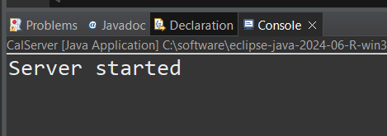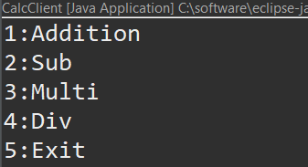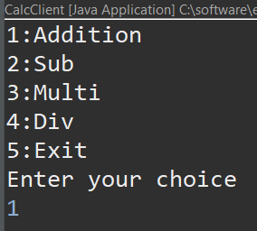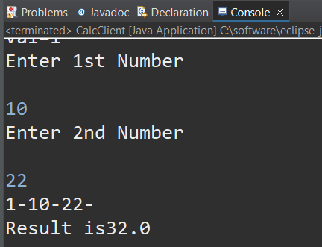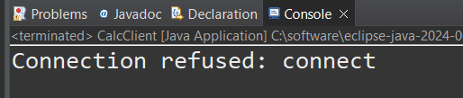

**Q.2 Write a java to implement a Date Time Server using RPC concept. (Make use of datagram).**

**Structure :**

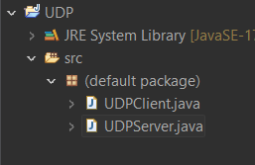

**Program :**

**UDPClient.java**

import java.io.IOException;

import java.net.DatagramPacket;

import java.net.DatagramSocket;

import java.net.SocketException;

public class UDPClient {

public static void main(String[] args) throws SocketException {

// TODO Auto-generated method stub

DatagramPacket dpac;

DatagramSocket dsoc = new DatagramSocket(1314);

byte[] b = new byte[64];

String data = "No Data";

System.out.println("Client up");

try {

while(true) {

dpac = new DatagramPacket(b, b.length);

dsoc.receive(dpac);

data = new String(dpac.getData());

System.out.println("We received Data : " + data);

}

}catch (IOException e) {

// TODO: handle exception

System.out.println("IOException");

}

dsoc.close();

}

}

**UDPServer.java**

import java.io.IOException;

import java.net.DatagramPacket;

import java.net.DatagramSocket;

import java.net.InetAddress;

import java.net.SocketException;

import java.util.Date;

public class UDPServer {

public static void main(String[] args) throws SocketException {

// TODO Auto-generated method stub

DatagramPacket dpac;

DatagramSocket dsac = new DatagramSocket();

System.out.println("Server up");

try {

while(true) {

System.out.println("Sending");

Thread.sleep(1000);

String time = new Date().toString();

byte b[] = time.getBytes();

dpac = new DatagramPacket(b, b.length, InetAddress.getByName("localhost"), 1314);

dsac.send(dpac);

}

} catch (IOException | InterruptedException e) {

// TODO: handle exception

System.out.println("IOException");

}

dsac.close();

}

}

**Output :**

